registered charity number 1151541
ANNUAL MEMBERSHIP & PARENTAL CONSENT FORM – 1st September 2018 – 30th September 2019

Dear young person and their parent / carer,

Seeds4Success is a local youth work charity providing developmental opportunities to young people in South West Wiltshire. We aim to deliver a variety of projects including practical conservation work and reward opportunities through our Leisure Credits Scheme, programmes targeted at young people with SEND to enhance their social and physical development, a leadership programme to develop the young person’s committee for the charity and to grow peer leaders to support our youth work offer to younger members, activities to promote health and wellbeing, specific projects to develop young people’s skills, 1:1 and small groupwork sessions that support young people who are Not in Education, Employment or Training and open access youth work opportunities.

All young people wishing to access any service or activity delivered by or provided by Seeds4Success and their parent/guardian (unless 18 or over) are required to complete and sign this form. This is a requirement of our insurers and under General Data Protection Regulation (GDPR) (EU) 2016/679, Seeds4Success is legally required to obtain consent to hold your personal data and you have a legal right to be informed about how we use any personal information that we hold about you. To comply with this, we provide a ‘privacy notice’ to individuals where we are processing their personal data - a copy of our full privacy notice can be obtained from jaki@seeds4success.org.uk

Seeds4Success, registered charity number 1151541, is committed to protecting your personal information and being transparent about what information we hold. We ensure that we use your information in accordance with all applicable laws concerning the protection of personal information.

Privacy notice:
This privacy notice explains how we collect, store and use personal data about children and young people who participate in our various youth work activities and projects and their parents / carers.

Seeds4Success, Mere Youth Centre, The Recreation Ground, Queens Road, Mere. BA12 6EP, are the ‘data controller’ for the purposes of data protection law. The lead worker for data protection is Jaki Farrell and lead trustee for Data Protection is Andy Nobel.

The personal data we hold about you:
We hold some personal information in order to provide accessible, appropriate and safe activities. This information may include:
• Name, Address and Contact details including mobile phone numbers & emails
• Date of birth and gender
• Next of kin and emergency contact details
• Details of any behaviour or learning issues
• Safeguarding information
• The name and address of the family GP
• Photographs & videos of your participation in our projects and activities
• Details of sessional / project attendance and participation, any specific outcomes or achievements including accreditation and awards
• Personal feedback about your experiences of our project / activities and your personal development through their engagement

We may also collect, store and use information about you that falls into "special categories" of more sensitive personal data. This includes information about (where applicable):
• Race, ethnicity, sexual orientation and religious beliefs
• Health, including any medical conditions and medication currently being prescribed

Why we use and store personal data about you
We only collect and use personal data when the law allows us to. The purpose of processing this information is to help us ensure children/young people are safe to participate in activities they enjoy, and that the charity is appropriately and lawfully managed. This includes:
- Getting in touch with parents, carers and young people to notify them about projects, activities, pick up arrangements or to discuss any specific concerns / issues
- Looking after the wellbeing of children and young people participating in our activities, taking into account their medical, learning, and social needs as appropriate
- Complying with health and safety obligations, completion of the accident book and RIDDOR reporting
- Ensuring the welfare of children and young people through communication with other support agencies / professionals working with the children/ young people to address any safeguarding concerns
- Promoting the charity through local media, on the website and social media pages
- To provide evidence of outcomes, achievements, training records, qualifications and appropriate use of funds to funding bodies and potential future employers or educational establishments

How we store this data
We keep personal information about you whilst you are participating in or supporting our activities and projects. We may keep it longer if this is necessary in order to comply with our legal obligations. Information is stored securely in our office at Mere Youth Centre.

The personal data we collect may be held as an electronic record on secure data systems or as a paper record in locked filing cabinets. The records are only seen by those who need the personal data so they can do their job. The security of the data follows Seeds4Success’s Data protection policy.

How long do we keep this data
Seeds4Success will keep and securely store consent and membership information and any other personal information relating to an individual young person for 3 years after they stop engaging with us, unless otherwise required by contract with external funding bodies. For example, all annual consent forms from the year Sept 2014 – October 2015 will be destroyed in October 2018, however, records of personal development and outcomes achieved will be kept until 3 years after the last time a young person accessed our services. The only exception to this would be copies of original certificates that young people have asked us to hold for safekeeping.

Data sharing
We do not share personal information about you with anyone outside the charity without consent, unless the law and our policies allow us to do so. Where it is legally required, or necessary (and it complies with data protection law) we may share personal information with:
• The local authority – to meet our legal obligations to share certain information with them, such as safeguarding concerns and exclusions
• Your family and representatives
• Our regulators e.g. the Charity Commission, HMRC, Peoples Pension, HSE etc.
• Suppliers and service providers such as outdoor activity instructors – to enable them to provide the service we have contracted them for
• Health authorities
• Police forces, courts, tribunals
• Professional bodies

In certain circumstances, this information may be shared even if you are no longer accessing our activities/projects.

Access to your information and correction:
You have the right to find out what personal information we hold about you, and how we use it, by making a ‘subject access request’, if we judge that you can properly understand your rights and what they mean. To request a copy of this information, please email jaki@seeds4success.org.uk with the heading ‘subject access request’

We want to make sure that your personal information is accurate and up to date. You may ask us to correct or remove information you think is inaccurate.

You have the right to withdraw consent at any time by emailing jaki@seeds4success.org.uk with the heading ‘GDPR – I want to opt out’

This may result in your being unable to continue with Seeds4Success activities if consent is a legal requirement.

CONSENT:
The attached Seeds4Success Annual programme consent and membership form covers the activities listed as well as transport to and from these activities and, as stated earlier, we are required by our insurers to obtain updated forms each year, which we do during the month of September, regardless of when you completed your form for the previous year. Apologies if this feels like a chore but these are for the safety and protection of your child/ward. By signing this consent from you will be agreeing to your son/daughter/ward taking part in the activities listed below (unless you indicate you do not wish them to), and agreeing to the young person being transported by minibus, taxi or private car with the appropriately qualified drivers to and from activities.

Please note that when accessing this transport, we expect young people to attend the youth work session that is running and then get the return transport home – any variance from this must be agreed in advance by parents / carers with the lead worker.

Young People without current completed membership and consent forms may be refused access to a session / project or be unable to access the transport.

Seeds4Success provides 3rd Party Liability Insurance as do the activity providers, however, we are unable to provide personal accident or injury insurance and it is the choice of the individual should they wish to organise this themselves.

In order to provide these opportunities to young people our staff and trustees work hard to raise money through grants and donations, many of which require us to report on the development of young people and the difference our charity has made to them, therefore if you are able to provide us with feedback about our service, and young people participate in user surveys, this is of benefit to us. We hope to be able to continue to deliver the existing range of opportunities over the coming year free of charge to young people however, this will be dependent on the funds the charity is able to raise.

We ask that young people respect our ground rules by not smoking in or around any buildings and by not bringing or consuming illegal substances or alcohol before or during any of the sessions. Any young person in breach of these rules will be asked to leave the session and parents/guardians will be required to collect them from wherever they are at their own cost as they will not be permitted on any return transport we provide.

If you have any questions, please contact me
Yours sincerely,
Jaki
Jaki Farrell
Service Manager Seeds4Success
Mobile: 07585 723824
email: jaki@seeds4success.org.uk

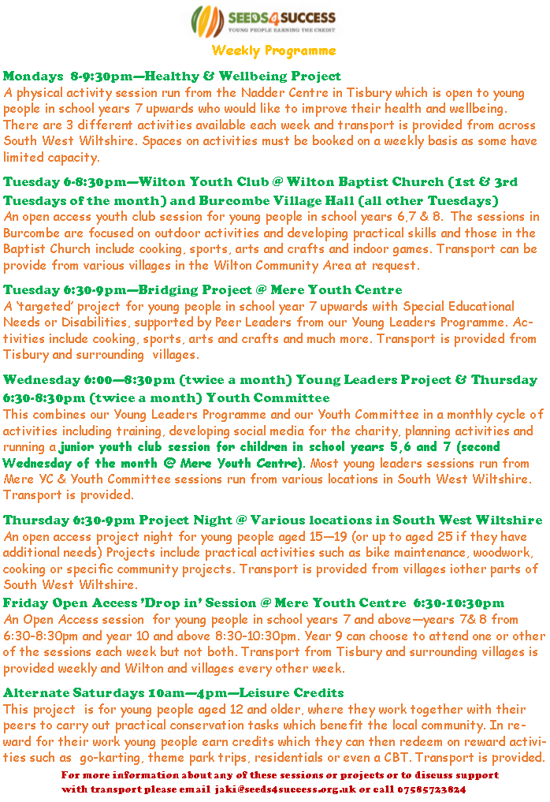
Annual Membership & Parental Consent Form 2018/19
By providing the necessary details on this form you will be giving permission for the young person to attend activities organised by Seeds4Success and to the sharing of such information to partners and funders.
Young Person Personal Details
First Name |  | Surname
Date of Birth | _ _ / _ _ / _ _ _ _ | Tel no.
Address
 |  | Postcode
Primary Emergency Contact Details
Name |  | Relationship to Young Person
Tel. no |  | Email
Address -if different from YP
Secondary Emergency Contact Details
Name |  | Relationship to Young Person
Tel. no |  | Email
Address
Young Persons identity
Please state the young person ethnicity
Does the young person identify as having a learning difficulty / disability |  | Yes |  | No
Activities
Our Youth Work Programmes may include the following activities. Please place a cross in the box next to any activities you wish your son/daughter/ward to be excluded from. All activities are delivered by experienced and appropriately qualified staff with the necessary clearances to work with young people.
Abseiling |  | Archery |  | Arts and crafts activities
Bowling |  | Canoeing/kayaking |  | Caving
Cinema Trips |  | Conservation and construction |  | Dance / Drama
Fitness activities and gym use |  | Fundraising Activities |  | Go karting
Healthy Eating & cookery |  | High Ropes |  | Ice/Roller Skating
Mechanics |  | Mountain Biking / Cycling skills |  | Music
Orienteering |  | Outdoor Survival Skills |  | Quad Biking
Raft Building |  | Rifle Shooting |  | Rock Climbing
Sailing/Wind surfing |  | Sports |  | Surfing
Swimming |  | Team Building Activities |  | Theme Park Trips
Training Courses |  | Website development& social media |  | Woodwork
Volunteering Activities
Medical Information
Name of GP |  | Telephone:
Address
Can you swim 50 metres unaided? | Yes No | Date of last anti tetanus injection | _ _ / _ _ / _ _ _ _

Does the young person have any of the following allergies or medical problems?
Asthma | Yes |  | No
Epilepsy | Yes |  | No
Diabetes | Yes |  | No
Acute allergies (e.g. nuts, stings, medications) | Yes |  | No
Allergies | Yes |  | No
Serious illness (e.g. heart conditions) | Yes |  | No
Injuries (e.g. fractures) | Yes |  | No
Other | Yes |  | No
If any of these are yes please detail below:

Are you allergic to aspirin/paracetamol? | Yes |  | No

Please tick if you consent to your son/daughter/ward being given an aspirin or paracetamol for minor ailments such as headaches if needed?
Aspirin |  | Paracetamol

Are you currently taking any form of medication?
Yes |  | No
If yes please give the name, dose and frequency of the medication:

Do you have any dietary needs? (e.g. vegetarian, wheat free)
Yes |  | No
If yes please detail:

Is there anything else we should be aware of? (e.g. ADHD, behavioural issues, special needs)
Yes |  | No
If yes please detail:

Are there any additional aspects of your young person’s health/diet that require treatment or special attention, which are not sufficient to prevent them attending sessions? If so, please state these below, including particular activities in which they should not participate for health reasons:
If this box is left blank we will assume you are happy for your son/daughter/ward to take part in all activities.

Consent:
Please be aware that under the GDPR May 2018, you are required to ‘opt in’ to by circling the relevant questions on all the following page. If all questions and sections on this form are not completed, it will be assumed that consent is not provided

This section must be completed by the parent or guardian:

May we use your young person’s photograph in printed publications for Seeds4Success or in articles or in printed publications that promote the work of Seeds4Success. | Yes | No
May we use your young person’s image on the Seeds4Success web sites and on our official social media pages? | Yes | No
Do you give permission for your young person to be named (i.e. not anonymous) in publicity or promotional material? | Yes | No
May we make direct contact with your young person via text message from Seeds4Success staff in relation to youth work activities | Yes | No
Do you give permission for your young person to follow or like the official Seeds4Success social media sites and for Seeds4Success staff to use messaging applications such as Whatsapp to make direct contact with them in relation to youth work activities | Yes | No

This section must be completed by the young person:
May we use your photograph in printed publications for Seeds4Success or in articles or in printed publications that promote the work of Seeds4Success. | Yes | No
May we use your image on the Seeds4Success web sites and on our official social media pages? | Yes | No
Do you give permission for your name to be used in publicity or promotional material? | Yes | No
May we make direct contact with you via text message by Seeds4Success staff in relation to youth work activities | Yes | No
Do you give permission for the official Seeds4Success social media sites to like and follow you and for Seeds4Success staff to use messaging applications such as WhatsApp to make direct contact with you in relation to youth work activities | Yes | No

Declaration: Parents (under 18’s)

- I have read the information about the programme and understand that if I have any queries I can discuss them with the staff from Seeds4Success
- I consent to Seeds4Success holding, using and lawfully sharing the personal data contained on this form for the purposes of health and safety, safeguarding, monitoring and evaluation or reporting to funders.
- I am satisfied that all reasonable care will be taken for the safety of those participating and that adequate staffing and safety measures have been arranged.
- I understand the extent and limitations of the insurance cover provided and that while Seeds4Success staff are in charge they will take all reasonable care of the young people and unless they are negligent they cannot be held responsible for any loss, damage or injury suffered by any child arising during events.
- I consider my son/daughter/ward to be medically fit to participate in the activities outlined and agree to inform you should this situation change between now and the date of any activity
- I understand that while my son/daughter/ward is participating in the project they will be subject to the project’s general code of behaviour and will be required to obey the instructions and advice of project workers and accompanying adults, otherwise they may be sent home if necessary.
- *In the event of an accident or illness I understand that every effort will be made to contact me but, if this is not possible, I authorise the project leader to consent to any medical treatment including inoculations, surgery or blood transfusions from a qualified medical practitioner which, in the opinion of the qualified medical practitioner, may be necessary for my child in the course of the programme, project or offsite activity.

By completing and signing this form, you are agreeing to the named Young Person participating in sessions and activities delivered by or on behalf of Seeds4Success from 1st September 2018 – 30th September 2019. The personal information you provide is for the purpose of health, safety, monitoring and evaluation and it will not be processed, or disclosed, in any way incompatible with that purpose. In accordance with the General Data Protection Regulations 2018, the information may only be disclosed to the Data Subject (yourself unless 18 or over) or with your consent. We will only share this information with others for the purpose of youth work delivery as necessary. Please also note this information will however, be passed on without permission, if there is a legal requirement to do so, or, if there is a risk of harm or threat to life.

Signature of Parent/Guardian/Carer _____________________________________________________________
Print name:_________________________________________________ Date: ________________________________

Declaration: PARTICIPANT (All)

I, as a participant in the stated activity, agree to abide by the rules and act upon the instructions of staff.

Signature of Participant_____________________________________________________________

Print name:__________________________________________________ Date: ________________________________

* Note The medical profession takes the view that parents’ consent to medical treatment cannot be delegated. This view is explicit in the Child Act 1989. Thus, medical consent forms have no legal status and a doctor/nurse insisting on a particular treatment has the right to do. However, it can be a comfort to medical staff to have general consent in advance from parents.

